AREA OF COMPOUND SHAPES
OCR GSCE – Monday 12 November 2018 – Paper 6 (Calculator) Higher Tier
1.
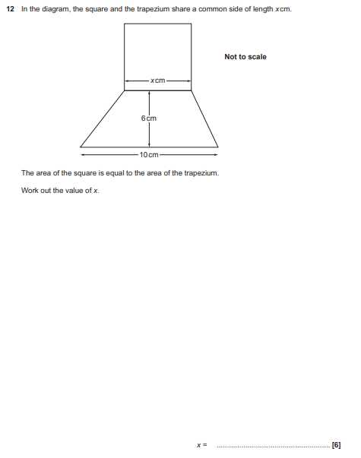

AQA GSCE – Thursday 8 June 2020 – Paper 3 (Calculator) Higher Tier
2.
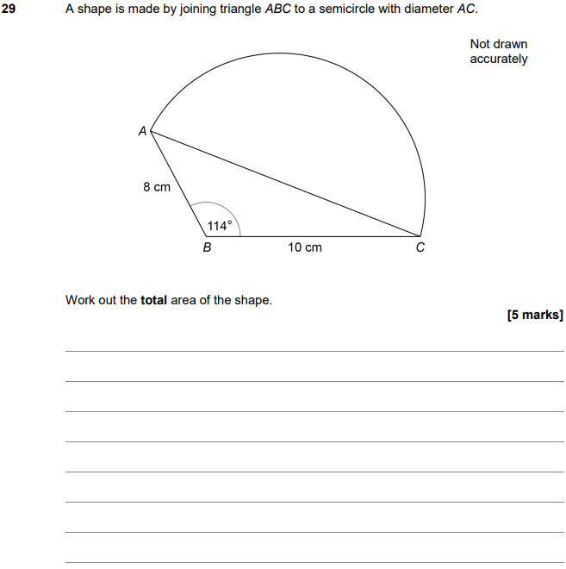

AQA GSCE – Thursday 8 November 2018 – Paper 2 (Calculator) Higher Tier
3.
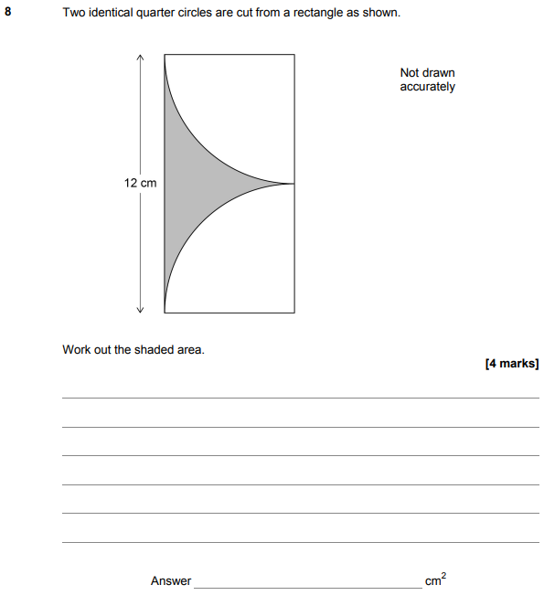

AQA GSCE – Wednesday 25 May 2017 – Paper 1 (Non - Calculator) Higher Tier
4.
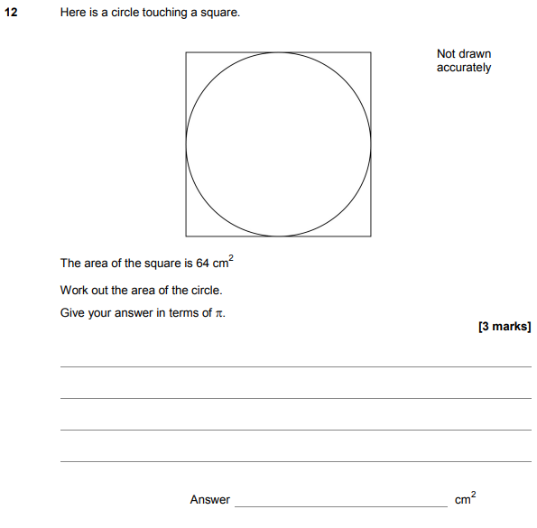

AQA GSCE – Tuesday 13 June 2017 – Paper 3 (Calculator) Higher Tier
5.
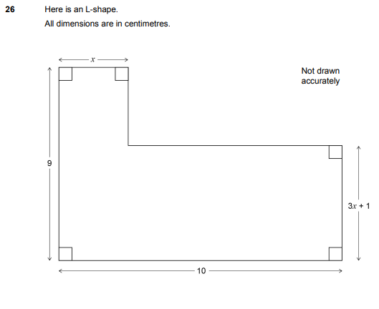
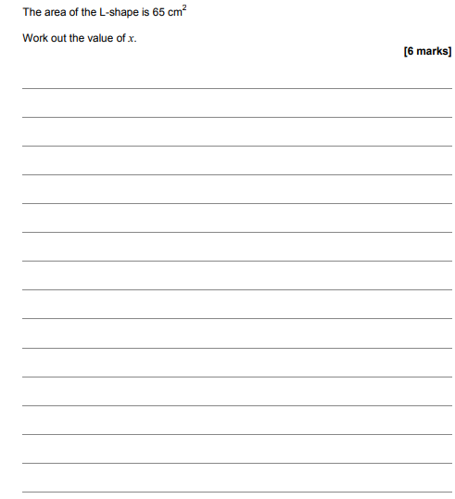

AQA GSCE – Sample Paper 1 (Non - Calculator) Higher Tier
6.
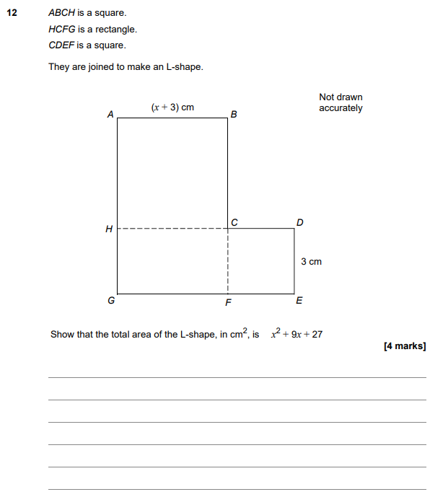

AQA GSCE – Sample Paper 2 (Calculator) Higher Tier
7.
